BAS Seed Fund 2021 (now Small Grants for Initiatives in Aphasia) Final Report
The Art of Conversation with Aphasia: a telehealth participatory art and communication partner training course
The Art of Conversation with Aphasia (ACA) is a telehealth group therapy that brings a Better Conversations approach to communication partner training together with participatory art to enable participants to live well with aphasia. Our project aimed to evaluate 1) the effect of the ACA course on the conversations and wellbeing of participants, and 2) participant views of the ACA course. The project team were members of Say Aphasia: Colin Lyall, Lauren Lyall, Hanka Mayhew, Chris Pomfrey, Paul Stocken; Ashley McCormick, former Head of Learning and Participation at the De La Warr Pavilion (DLWP), a cultural centre on the south coast; Suzanne Beeke and Firle Beckley from UCL’s Better Conversations Lab; Nikki Hafter, artist facilitator; and Amy Sherman and Fien Barnett-Neefs, former UCL students who are now newly qualified speech and language therapists. The ACA project was funded from February 2020 to July 2021 by a UCL Innovation and Enterprise grant, and the Covid-19 pandemic shaped the project in significant ways; all but one team meeting was held on Zoom and so was the group therapy.
Inspired by films we saw at the BAS Clinical Symposium 2019, we wanted to use our recordings of remote team meetings and of the group therapy to make a film about the ACA project. Our BAS funding allowed us to make this film and to have an event to showcase it. Our team included Ben Goldstein, a film editor living with aphasia. We held remote meetings to storyboard the film, choose video clips for inclusion, and give feedback on an early version. Our event - the Big Meet Up – was held at the DLWP in Bexhill-on-Sea. This brought together ACA therapy participants for the first time (the group itself was delivered over Zoom), and it was only the second time the project team had met in-person. At the celebration we watched the film together, visited the exhibitions in the gallery and took and shared photos ‘through the cut out’ (see photo).
The film is something the whole team contributed to and we are very proud of it. We have been absolutely thrilled by people’s reactions to it. Some feedback from SLTs includes “wonderful video – really demonstrated the huge impact this work has had”, “good way to raise awareness” and “inspirational”.
Key outcomes of this Initiatives in Aphasia award are:
- the ACA film (9 minutes, aphasia accessible), which is on YouTube https://youtu.be/q4UJedzPoZ4
- the Big Meet Up, an in-person celebration and film screening (see photo)
- project dissemination: we presented the film at BAS RUM June 2021, and Farley House Group (creativity and wellbeing collective in East Sussex) July 2021; we also shared it with Head of Digital Inclusion East Sussex County Council
- funding for Zooming Great, a Say Aphasia spin-off from the ACA project to pilot ways to get digitally excluded people online and build their confidence and digital skills so they can then take part in online therapy. We included the film in applications to the funders, the Ernest Klienwort Charitable Trust, and Sussex Community NHS Foundation Trust.
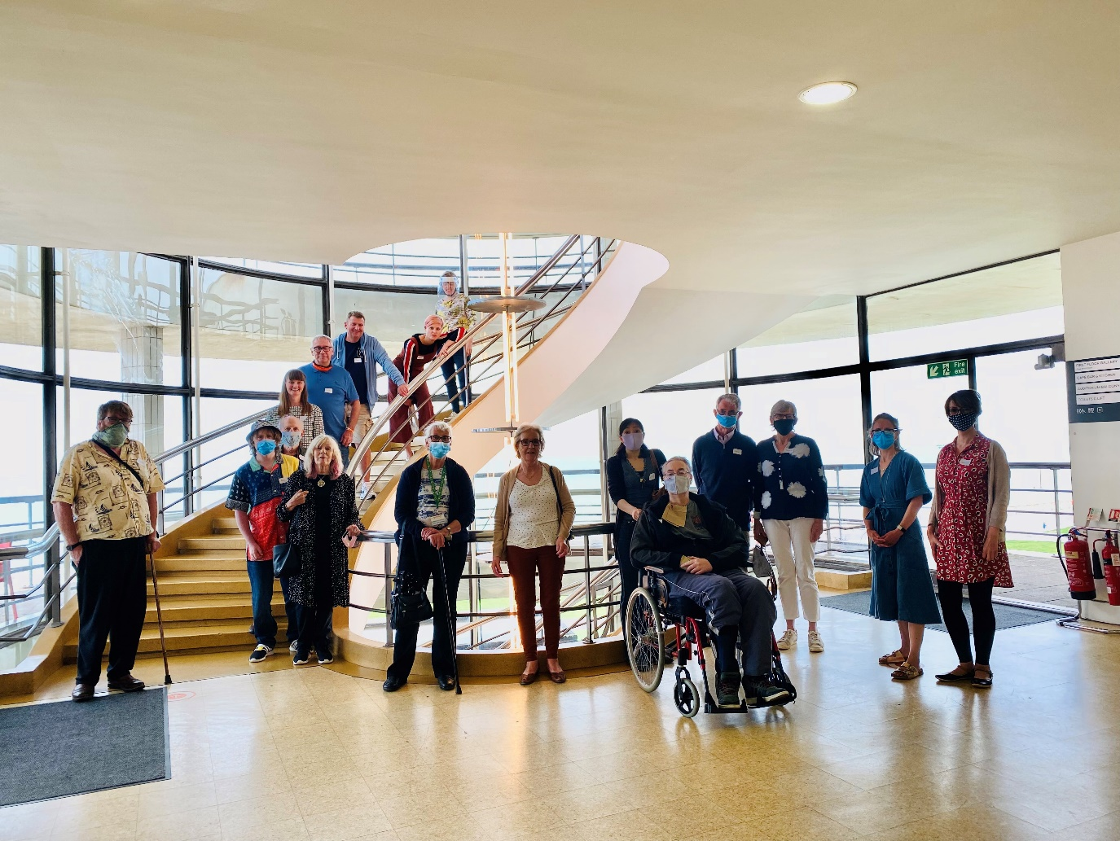
1 ACA Big Meet Up June 2021 at De La Warr Pavilion

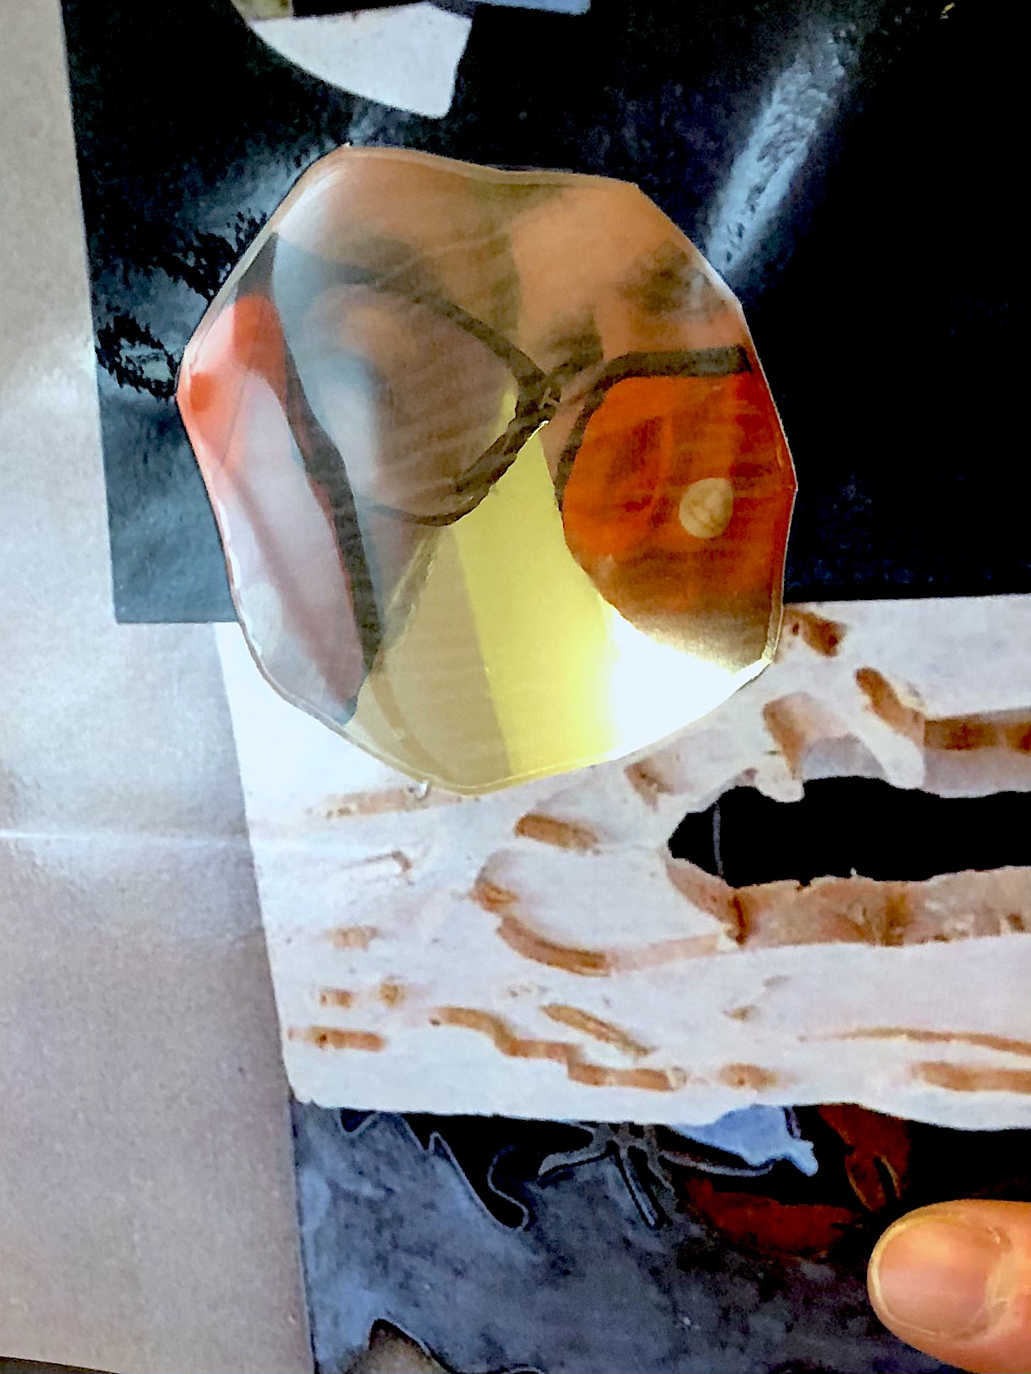
2 Colin and Paul 'through the cut out' at ACA Big Meet Up June 2021 at De La Warr Pavilion

