BAS IASF 2016 Final Report

Project: Core Outcome Set (COS) consensus and dissemination meeting and consumer research feedback seminar. Phase 3 of ROMA: Improving Research Outcome Measurement in Aphasia
Dr Madeline Cruice & Dr Sarah Wallace with Professor Linda Worrall, Dr Tanya Rose, and Professor Guylaine Le Dorze
The project comprised two events held at City, University of London in December 2016:
- A feedback seminar for people with aphasia, family members, and stroke aphasia group coordinators on the research findings of what are important outcomes in aphasia rehabilitation; and
- A consensus and dissemination meeting with international aphasia researchers, to research consensus on a core outcome set (a minimum set of outcomes and corresponding outcome measures) for aphasia treatment research.
The importance of measuring outcomes that are important to consumers and informed by consumers is increasingly recognised. Constructs that are most often measured in RCTs of aphasia treatment are impairment; a question remains in research as to whether we are measuring what matters to key stakeholders. 39 people with aphasia and 29 family members in seven countries – Australia, Canada, Denmark, Hong Kong, South Africa, the UK and the USA – took part in discussions using the nominal group technique, to gain consensus on important outcomes. Sarah Wallace presented these findings in an accessible way to 46 people with aphasia, family members, stroke group coordinators, and speech and language therapy students who responded to the Eventbrite listing. Sarah’s accessible presentation is available as a separate PDF attachment (see separate file), and her paper is available: https://www.ncbi.nlm.nih.gov/pubmed/27345867 Findings indicate that whilst language functioning and impairment is important, outcomes that consider activity & participation, and the environmental context, are also important to people with aphasia and family members.

A core outcome set (COS) is urgently needed in aphasia treatment research. The 2016 systematic review of aphasia therapy (Brady et al. 2016) highlighted the varied use of outcome measures: 44 different outcome measures were used across 57 different trials. COSs are agreed standard sets of outcome constructs and outcome measures that are used routinely in treatment trials. Having a consistent set of outcomes facilitates data combination and comparison across studies, as well as acting as a deterrent to selective reporting of outcomes. Data from four studies by Wallace and colleagues were synthesized as a foundation to make decisions for the COS meeting: 3 consensus based studies eliciting stakeholders’ view of important outcomes (people with aphasia and family members; aphasia clinicians and managers; aphasia researchers) and one systematic review of the measurement properties of outcome measures validated for use in aphasia. This revealed a COS needed to include measures of language, emotional wellbeing, communication, health services, and quality of life. As there are no validated measures of health services, measures in only 4 areas were considered. Selection criteria were applied to identify the most robust and feasible measures to consider. 24 researchers and 2 researchers on Skype from 7 countries participated in the COS consensus meeting. Consensus (more than 70%) was reached for the Western Aphasia Battery Revised, the General Health Questionnaire-12, and the Stroke and Aphasia Quality of Life Scale. Consensus could not be reached for communication; and participation was identified as an important construct. The COS will be revisited regularly, and Dr Wallace is currently leading write-up of the meeting report for publication.
s.wallace3@uq.edu.au
@SarahJWallace
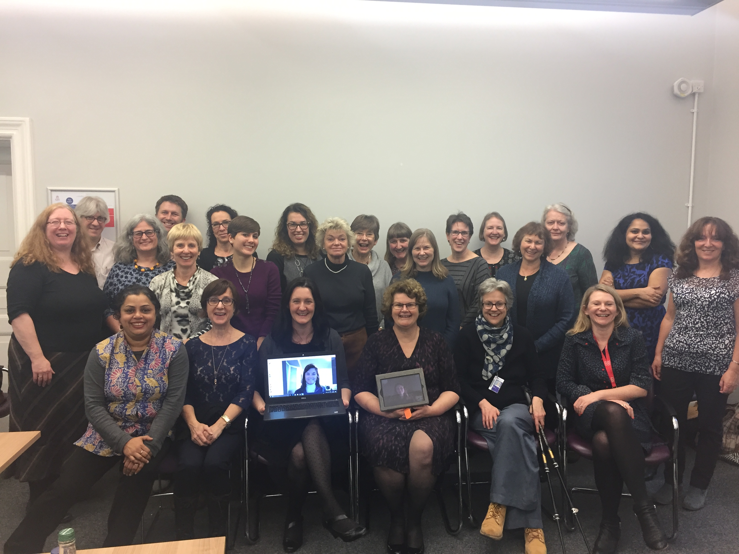
Participants in ROMA COS Consensus Meeting, 13th December 2016 City, University of London

